Gulf Atlantic is proud to represent McLanahan Corporation, enabling us to provide you with a complete range of mineral and aggregate processing equipment for washing, classifying, crushing, mixing, feeding, dewatering, scrubbing, and screening products such as limestone, granite, sand, gravel, coal, rock, salt, iron ore, wood chips, clay and more.
The McLanahan product line is recognized world-wide as one of the most reliable and versatile engineering, design, and manufacturing companies in the industry. Holding many patents, from the 1800s through today, the dedicated employees of McLanahan Corporation continually update and modernize aggregate and mineral processing equipment that is reliable, effective, highly productive, and low maintenance – improving your operation’s efficiency and profits.
McLanahan has always been leader in innovation, patenting the first Log Washer in 1981, inventing the Single Roll Crusher and producing the first “Bradford Breakers” which would later become known as Rotary Breakers. Now, with the recent acquisition of the legendary line of heavy crushing equipment designed and built by Universal Engineering, McLanahan offers a full range of material handling equipment for your existing operations and future projects. All this and more is now available to you through Gulf Atlantic!  And, if you have a frac sand project, Gulf Atlantic is able to provide you with both stationary and portable McLanahan Frac Sand Processing Equipment.  Whether you need mineral or aggregate processing equipment, repair parts, or just need input on your next project, contact Gulf Atlantic – your McLanahan dealer – at 800-792-7427.  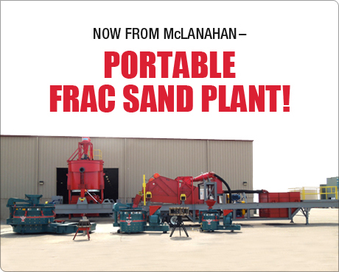  Call 800-792-7427 or 352-628-6674 for Details ! | The photos below are for a slide show on this page like the one shown on the manufacturer’s page: http://www.mclanahan.com/index.php?page=aggregate-dewatering-screens  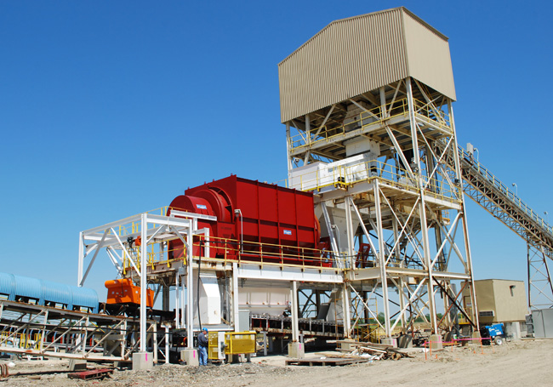  Rotary Breakers are used in the primary and secondary reduction of ROM coal and in the separation of rock and mine refuse. Currently McLanahan offers two Rotary Breaker models - the Heavy-Duty Rotary Breaker and the Standard-Duty Rotary Breaker.  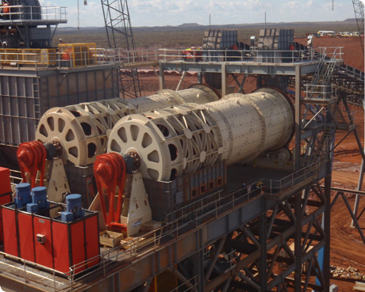  McLanahan Rotary Scrubbers are cost-effective washing units that are an  integral part of a material handling system to upgrade a wide variety of  primary crushed hard rock and ore.  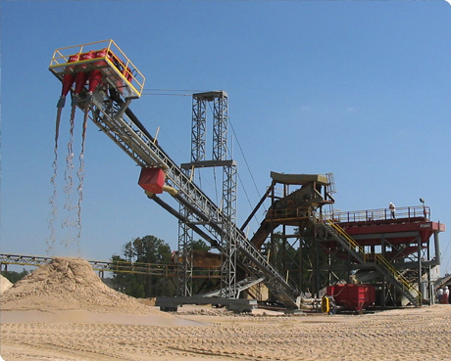  Hydrocyclones, or more simply Cyclones, and derivatives such as the  McLanahan Separator™ are used in many varied applications including  classification, desliming, fines recovery and dewatering.  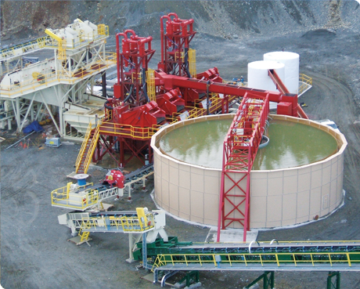  McLanahan’s high-rate Thickeners are simple in design and operation with  specific benefits for today's producers. After having removed usable materials  from the effluent stream, Thickeners recover immediately re-usable process  water adjacent to the plant site.  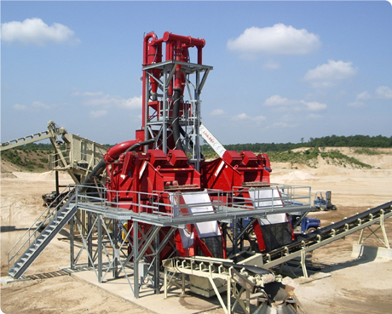  McLanahan Dewatering Screens feature custom-engineered, heavy-duty screen media for the high capacity applications in today’s production driven market. The screen’s robust design features heavy side plates, stress relieved bridges and cross-beams which are Huck-bolted together - not welded - so that individual components can be replaced.  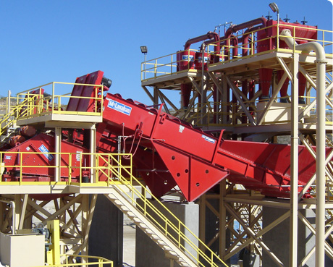  McLanahan Fine Material Screw Washers are primarily used to dewater,  classify and wash minus 3/8” sand or fine minerals. They are designed to  accept feed slurry from Sand Manager Classifying Tanks, Hydrocyclones, Hydrosizers™ and other Fine Material Screw Washers.  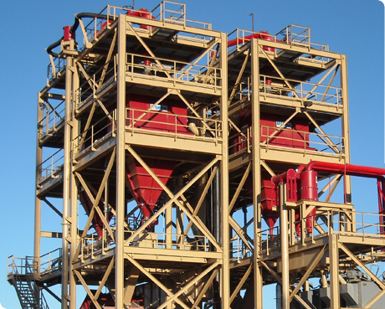  McLanahan Hydrosizers (Density Classifiers) for Frac Sand, construction  and specialty sand, aggregates, iron ore, phosphate, coal, mineral sand  and many other ore concentrates

Get the McLanahan Advantage

Find The McLanahan Product For Your Application – By Name or By Process

The McLanahan Product Line

Aggregate Conditioners
Attrition Scrubbers
Classification Tanks
Coarse Material Screw Washers
Crushers – Hammermill
Crushers – Jaw
Crushers – Primary Impact
Crushers-Roll
Crushers – Secondary Impact
Crushers – Stage Loader
DDC Sizers
Dewatering Screens
Feeders
Feeder-Breakers
Filter Presses
Fine Material Screw Washers
Fines Recovery Plant
Frac Sand Plants
Hydrocyclones
Hydrosizers (Density Separator)
Log Washers
Portable Plants
Pugmill Mixer

Process Needed | Equipment Available
Breaking | - Rotary Breakers
Classification | - Sand Manager Classifying Tanks
Contaminant Removal | - Attrition Scrubbers  - Lites Out (Flat Bottom)Classifier  - Coarse Material Screw Washer
Crushing | - DDC-Sizers – Primary, Secondary, Tertiary  - Hammermill Crushers  - Centerfeed Hammermills  - HammerMaster  - LimeMaster  - Minimac Hammermills  - Non-Clog Hammermills  - Standard Hammermill Crushers  - Jaw Crushers  - Primary Impact Crushers  - Andreas Primary Impact Crushers  - MaxCap Primary Impact Crushers  - New Holland Primary Impact Crusher  - VersaCap Primary Impact Crushers  - Roll Crushers – Single, Double, Triple, Quad  - Secondary Impact Crushers  - NGS Secondary Impact Crushers  - Standard Secondary Impact Crushers  - Stage Loader Crusher
Dewatering/Fines Management | - Dewatering Screens  - Recessed Fines Filter Press
Feed Preparation/Scrubbing  Pumps  Rotary Breakers  Rotary Scrubbers  Rotary Trommel Screens  Sampling Systems  Sand Plants  Screens  Separators  Thickeners | - Aggregate Conditioners  - Coarse Material Screw Washers  - Log Washers  - Rotary Scrubbers
Feeders and Feeder-Breakers | - Apron Feeders  - Crawler-Mounted Feeder Breakers  - Drag Feeders  - Reciprocating Plate Feeders  - Reclaim Feeders  - Stationary Feeder-Breakers  - Vibrating Feeders  - Wobbler Feeders
Fines Recovery  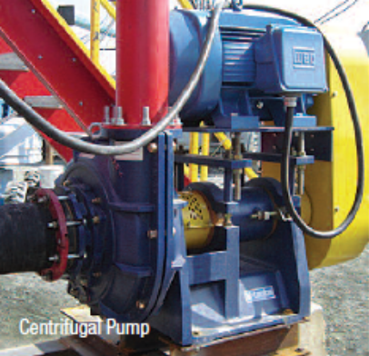 | - Hydrocyclones and Separators  - Hydrosizer (Density Separator)  - Ultra Fines Recovery Plant
Frac Sand Processing Equipment  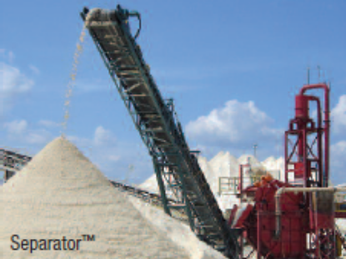 | McLanahan specializes in the design and manufacture of equipment and complete  wet processing systems for producing frac sands used in the oil and gas well drilling  industry.  - Attrition Scrubbers  - Centrifugal Pumps  - Dewatering Screws  - Hydrosizers  - Portable Frac Sand Plants  - Recessed Plate & Membrane Filter Presses  - Thickeners (Clarifiers)  - Complete Plant Design  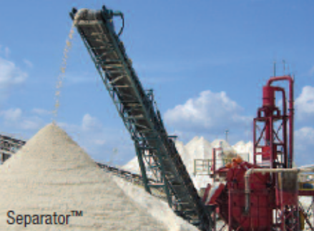
Mixing and Blending | - Pugmill Mixers  - Blendmaster  - Coalmaster  - Pugmaster
Portable Plants | - Portable Frac Sand Plants  - Custom Engineered & Designed Plants  - Open & Closed Circuit Plants Available
Pumps  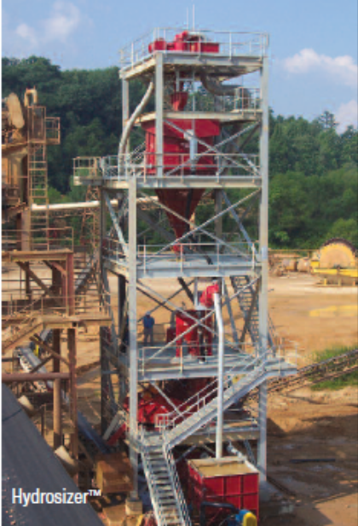 | - Horizontal spindle, centrifugal slurry pumps  - Vertical configuration  - Vortex Flow Impellers
Sampling Systems | - Specifically designed to capture material down  to sand grain in size.
Sand Processing | - Fine Material Screw Washers  - Frac Sand Plant  - Sand Manger Classifying Tanks  - Specialty Sand Plants  - In-Line Blending Sand Plants  - Recipe Sand Plants  - Ultra Sand Plants
Scrubbing and Washing | - Log Washers  - Rotary Scrubbers
Sizing and Screening | - Rotary Trommel Screens  - Screens  - Screenmaster  - Uni-Screen
Water “Fines” Management | - Recessed Plate Filter Press  - Thickeners

For more information or to receive a quotation on McLanahan Equipment, click here

Or Call 800-792-7427 or 352-628-6674


